TIẾNG ANH 6 FRIENDS PLUS | Final Second term - Test 2  Thời gian làm bài: 45 phút (Không kể thời gian giao đề)  -------------------------

I. Pronunciation
Câu 1. Which word has the underlined part pronounced differently from that of the others?
A. cable B. avatar C. far D. car
Câu 2. Which word has the underlined part pronounced differently from that of the others?
A. try B. probably C. exactly D. sunny
Câu 3. Which word has a different stress pattern from that of the others?
A. comment B. picture C. balloon D. landscape
Câu 4. Which word has a different stress pattern from that of the others?
A. extreme B. Antarctica
C. weather D. around
II. Choose the answer (A, B, C or D) that best fits the space in each question.
Câu 5. If it _____ tomorrow, we _____ at home.
A. rained / stayed B. rains / stayed
C. will rain / will stay D. rains / will stay
Câu 6. What will you do if you have a day off?
A. I watched that film. It was great.
B. Yes, my company has a day off tomorrow.
C. I will go hiking and spend time in nature.
D. I will give you my e-mail soon.
Câu 7. Yesterday, I _____ the house.
A. clean B. will clean
C. cleaning D. cleaned
Câu 8. If I _____ enough money, I _____ a new car.
A. had / bought B. will have / will buy
C. have / bought D. have / will buy
Câu 9. Listen! I think there is someone ______ the front door.
A. with B. at C. on D. in
Câu 10. The ________ travels at high speed through the galaxy.
A. plane B. spaceship C. boat D. car
Câu 11. Did you go on vacation last weekend?
A. Yes, I like shopping with friends. B. Yes, I love food.
C. No, I was too busy with my presentation. D. No, my flight is about to take off.
Câu 12. I’ll call you ______ seven o’clock.
A. at B. of C. in D. on
Câu 13. John is _________ and he plays basketball.
A. blonde B. straight C. tall D. dark
Câu 14. My sister is __________, but she sings really well.
A. curly B. grey C. short D. spiky
III. Look at the signs. Choose the best answer (A, B, C or D).
Câu 15.
What does this note mean?
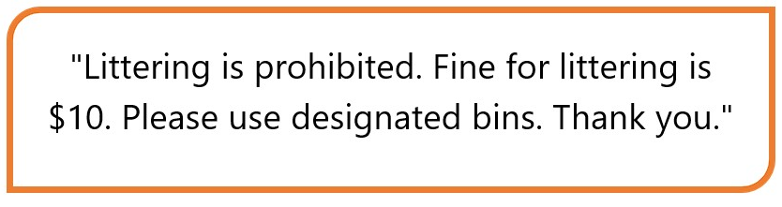
A. Littering is prohibited and violators will be fined $10.
B. Visitors can litter wherever they want.
C. Visitors are allowed to litter in this area.
D. Littering is allowed, but visitors must pay a $10 fine.
Câu 16.
What does this note mean?
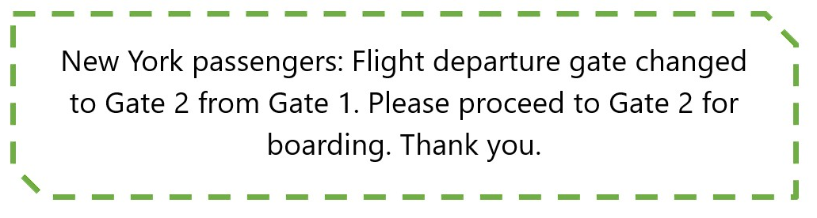
A. Passengers travelling to London should proceed to Gate 1.
B. Passengers should proceed to the gate immediately.
C. The departure gate for New York has been changed to Gate 2 from Gate 1.
D. The flight to New York has been cancelled.
IV. Read the following passage and do as direct.
Last summer, I took a trip to Nha Trang and it was amazing! The stunning beaches, warm weather, and delicious food made it a perfect holiday destination. I explored the local markets and found some great souvenirs to bring back home. Snorkeling in the ocean was the highlight of my trip as I saw some breathtaking sea creatures. Overall, Nha Trang was an unforgettable experience and I highly recommend it for anyone looking for a fun and relaxing vacation.
Câu 17. The writer took a trip to Nha Trang last summer.
A. False B. True
Câu 18. The weather in Nha Trang was cold during the writer's trip.
A. True B. False
Câu 19. The writer did not try any local cuisine while in Nha Trang.
A. True B. False
Câu 20. Snorkeling was not one of the highlights of the writer's trip to Nha Trang.
A. True B. False
Câu 21. What was one of the highlights of the writer's trip to Nha Trang?
A. Shopping at local markets B. Snorkeling in the ocean
C. Eating at fancy restaurants D. Visiting museums
Câu 22. What is the writer's overall recommendation for Nha Trang?
A. Good for a relaxing vacation B. Not worth visiting
C. Only good for adventurous travelers D. Best for budget travelers
V. Choose the word (A, B, C or D) that best fits the blank space in the following passage.
Dear Max,
I ____23____ this email finds you well. With the weather getting warmer, I thought it would be a great idea to plan a ___24_____ to the countryside. I would like to invite you to join me ____25____ a train trip to the beautiful countryside next weekend. We can ____26____ the scenic views and enjoy some fresh air away from the hustle and bustle of the city.
Let me know if you're ____27____, and we can plan the details together. I am looking forward to ___28_____ back from you soon.
Best regards,
Paul.
Câu 23. Choose the correct answer.
A. like B. hope C. enjoy D. want
Câu 24. Choose the correct answer.
A. concert B. hike C. trip D. party
Câu 25. Choose the correct answer.
A. at B. in C. on D. about
Câu 26. Choose the correct answer.
A. listen B. smell C. explore D. hear
Câu 27. Choose the correct answer.
A. interested B. bored
C. unwilling D. sick
Câu 28. Choose the correct answer.
A. hearing B. receive C. getting D. listen
VI. Supply the correct form of the word given in each sentence.
Câu 29. We are ____________ the train to go on vacation. [board]
Câu 30. She has ____________ hair that bounces when she walks. [curl]
Câu 31. My ____________ is that the home team will win the match today. [predict]
Câu 32. The weather looks ____________ for our picnic. [promise]
Câu 33. I am ____________ that I will succeed. [hope]
Câu 34. Let's go ____________ in the woods. [camp]
VII. Rearrange the groups of words in a correct order to make complete sentences.
Câu 35. along/stopped at/the route. /The tram/every station
_____________________________________________________________________
Câu 36. on stage/The famous/singer performed/her latest hit/last night.
_____________________________________________________________________
VIII. Rewrite each of the following sentences in another way so that it means almost the same as the sentence printed before it.
Câu 37. I will able to watch a movie with friends if I finish my work early today.
Unless I _____________________________________________
Câu 38. Mr. Kim cooks really well.
Mr. Kim is _____________________________________________
Câu 39. There were 1000 employees in this company last year.
This company consisted _____________________________________________
Câu 40. He was famous thanks to his invention.
His invention _____________________________________________
----HẾT---
Word | IPA | Word Class | Vietnamese Meanings
Last summer | læst ˈsʌmər | n | mùa hè năm trước
Trip | trɪp | n | chuyến đi, du lịch
Nha Trang | nha træŋ | n proper | Nha Trang
Amazing | əˈmeɪzɪŋ | adj | tuyệt vời, kỳ diệu
Beaches | ˈbiːtʃɪz | n | bãi biển
Warm weather | wɔrm ˈwɛðər | n | thời tiết ấm áp
Delicious | dɪˈlɪʃəs | adj | ngon miệng
Souvenirs | ˌsuːvəˈnɪrz | n | hàng lưu niệm
Snorkeling | ˈsnɔrkəlɪŋ | n | lặn có ống thở
Sea creatures | si ˈkritʃərz | n | sinh vật dưới biển
Hope | hoʊp | v | hy vọng
Trip | trɪp | n | chuyến đi, du lịch
On | ɒn | prep/adv | trên, vào
Countryside | ˈkʌntrisaɪd | n | miền quê, nông thôn
Invite | ɪnˈvaɪt | v/n | mời gọi, lời mời
Enjoy | ɪnˈdʒɔɪ | v | thưởng thức, tận hưởng
Interested | ˈɪntrəstɪd | adj | quan tâm, muốn tham gia
Hearing | ˈhɪrɪŋ | n | việc nghe, tin tức
Train trip | treɪn trɪp | n | chuyến đi bằng tàu hỏa
Scenic views | ˈsiːnɪk vjuːz | n | cảnh quan đẹp

