Week 12 - Period 34

THEME 4 – MUSIC AND ARTS – Lesson 2
LISTENING & SPEAKING&WRITING
Hướng dẫn học sinh tự học

I. Hướng dẫn học sinh tìm hiểu bài tự học
- Các em mở sách Student’s book trang 36 để làm bài Listening và trang 37 để làm Speaking
II. Nội dung ghi bài
- Các em làm trực tiếp bài Listening vào sách và luyện tập bài Speaking.
III. Luyện tập
- Listening
- Các em mở video clip hướng dẫn nghe kèm theo trên K12 để nghe và viết câu trả lời vào trong sách.
- Sau khi làm xong, các em nghe lại một lần nữa và kiểm tra đáp án.

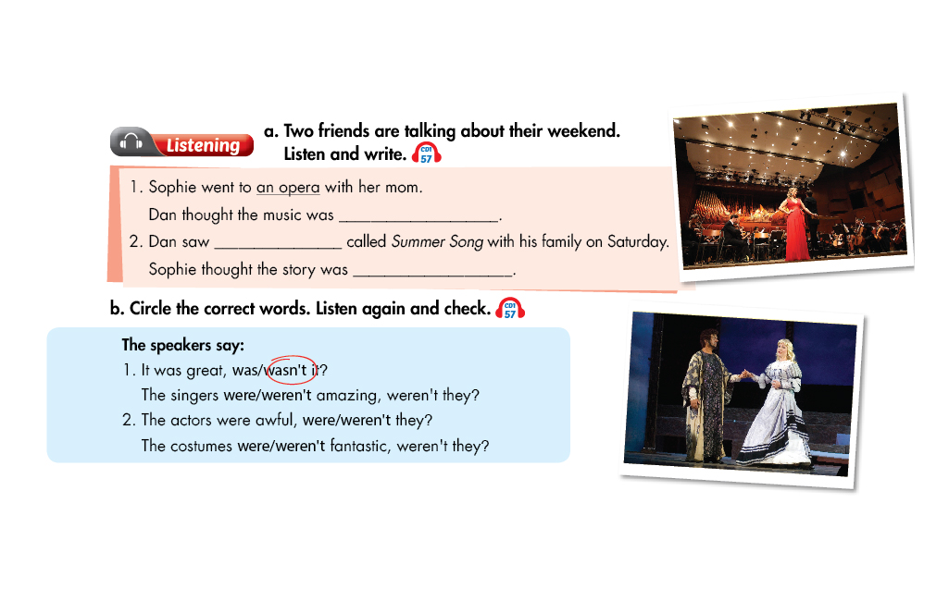

- Các em không có thiết bị nghe, có thể đọc nội dung bài nghe ở đây để làm bài nghe nhé:
Tapescript
Track 57
1. Dan: Hi Sophie. Did you have a nice weekend?
Sophie: Yes and no. I went to an opera called Madame Butterfly with my mom.
Dan: Oh, me too. It was great, wasn't it?
Sophie: Yes, it was. I really liked it.
Dan: I thought the music was really good.
Sophie: Me too! The singers were amazing, weren't they?
Dan: Yeah, they were. Sophie: The story was excellent, wasn't it?
Dan: No, it wasn't. I thought it was a bit boring.
2. Sophie: Did you do anything else?
Dan: Yes, I saw a play called Summer Song with my family on Saturday.
Sophie: I saw it too, with my grandparents.
Dan: It wasn't very good, was it?
Sophie: No, it wasn't. The actors were awful, weren't they?
Dan: Yes, they were.
Sophie: The only thing I liked was the costumes.
Dan: Yeah, the costumes were fantastic, weren't they?
Sophie: Yes, they were beautiful.
Dan: Did you like that story?
Sophie: No! The story was terrible, wasn't it?
Dan: Yes, it was awful.
Narrator: Now listen again and check.

- Speaking

- Các em sử dụng cấu trúc câu hỏi đuôi để nói về ý kiến của mình khi xem các buổi trình diễn
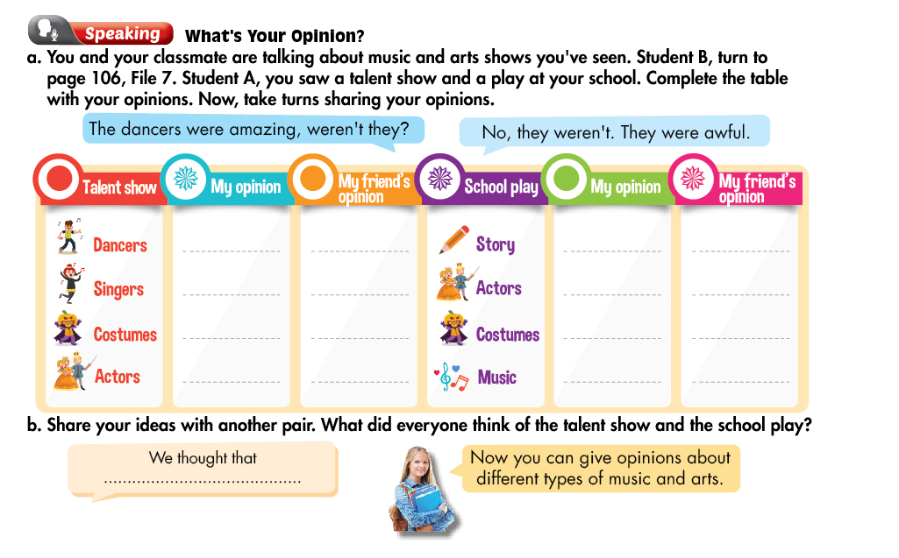
IV. Dặn dò
-Học từ vựng, ngữ pháp theme 4 – lesson 1,2
- Làm các bài tập của theme 4-lesson 1,2 trong sách WB
- Gửi bài cho tổ trưởng nhé.

Week 12 - Period 35

THEME 3: HEALTHY LIVING – EXERCISES

I. Nhiệm vụ của học sinh
- Các bạn xem lại từ vựng và cấu trúc ngữ pháp của theme 4-Lesson1+2.
- Làm bài tập vận dụng dưới đây

II. Nội dung bài học
A. Choose the word whose underlined part pronounced differently from that of the others:
1. …………….. music is originally from the south of the USA.
a. blues b. pop c. rock d. flamenco
2. …………….. music is very loud music with lots of electric guitars.
a. flamenco b. rap c. rock d. pop
3. The type of Spanish dance music which is very exciting is ……………...
a. rap b. flamenco c. rock d. pop
4. She prefers …………….. music. She loves listening to singgers rapping.
a. rap b. pop c. rock d. jazz
5. Lan loves listening to …………….. music. It’s popular in South Korea and around the world.
a. blues b. flamenco c. rock d. pop
6. …………….. music is originally from Jamaica. They often use the bass guitar.
a. rap b. reggage c. rock d. pop
7. The concert was fantasic, …………….. it?
a. were b. was c. wasn’t d. weren’t
8. The actors were awful, …………….. they?
a. were b. was c. wasn’t d. weren’t
9. I went to a pop …………….. yesterday to see Kathy Berry.
a. ballet b. concert c. play d. costumes
10. A …………….. tells a story and is performed in a theater.
a. opera b. concert c. play d. costumes
B. Put the verbs in brackets in the correct form.
1. He ……………… a reggage singer. (be)
2. Mary ……………… classicial to rock. (prefer)
3. The concert ……………… fantasic, wasn’t it? (be)
4. The singers ………………excellent, weren’t they? (be)
5. Sophie and her mother ……………… to the opera, didn’t they? (go)
C. Rearrange the words
- really/ I/ the costumes/ like/ didn’t/ the play/ in/
…………………………………………………………………………………….
- started/ eight/ at/ The school/ o’clock/ ,/ it/ didn’t/?
……………………………………………………………………………………..
- to/ I/ reading books/ prefer/ music/ listening to/.
…………………………………………………………………………………….
- very good/ The / weren’t/ dancers/ , / they/ were/?
……………………………………………………………………………………
- prefers/ My father/ pop music/ classical music/ to/.
……………………………………………………………………………………
D. Rewrite
- I like rock music better than blues.
I prefer…………………………………………
- She likes going skateboarding better than playing the guitar.
She prefers……………………………………
- They like country music better than flamenco.
They prefer………………………………………
- Were the dancers very good?
The dancers……………………………………..?
- Did you really like opera?
You …………………………………………….?
V. Dặn dò
- Ôn lại từ vựng, xem lại ngữ pháp của theme 4-Lesson 1+2
- Chụp hình bài ghi cho tổ trưởng nhé.

PERIOD 36: THEME 4: MUSIC AND ARTS
LESSON 4: HISTORY
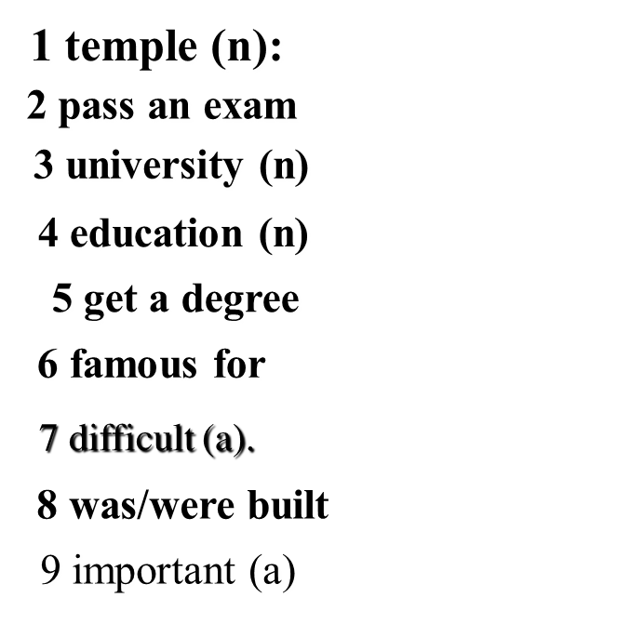
I. NEW WORDS
đền thờ
quan trọng
được xây dựng
khó
nổi tiếng
lấy bằng
nền giáo dục
trường đại học
thi đỗ
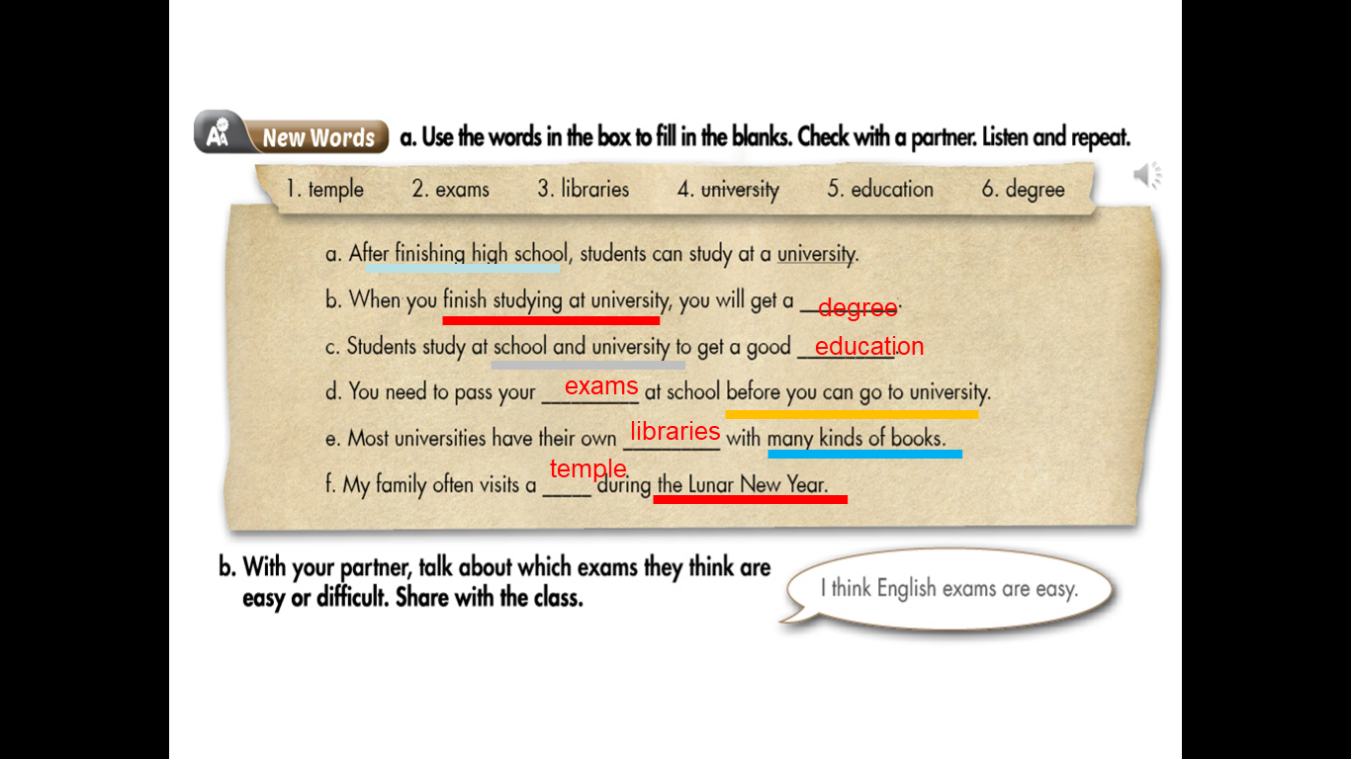

II. USEFUL LANGUAGE
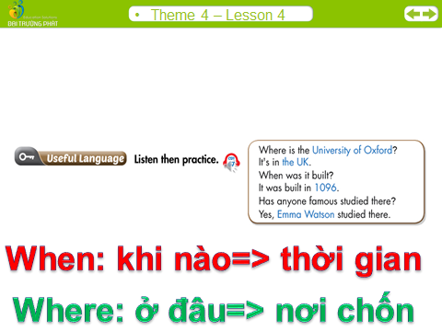
III READING
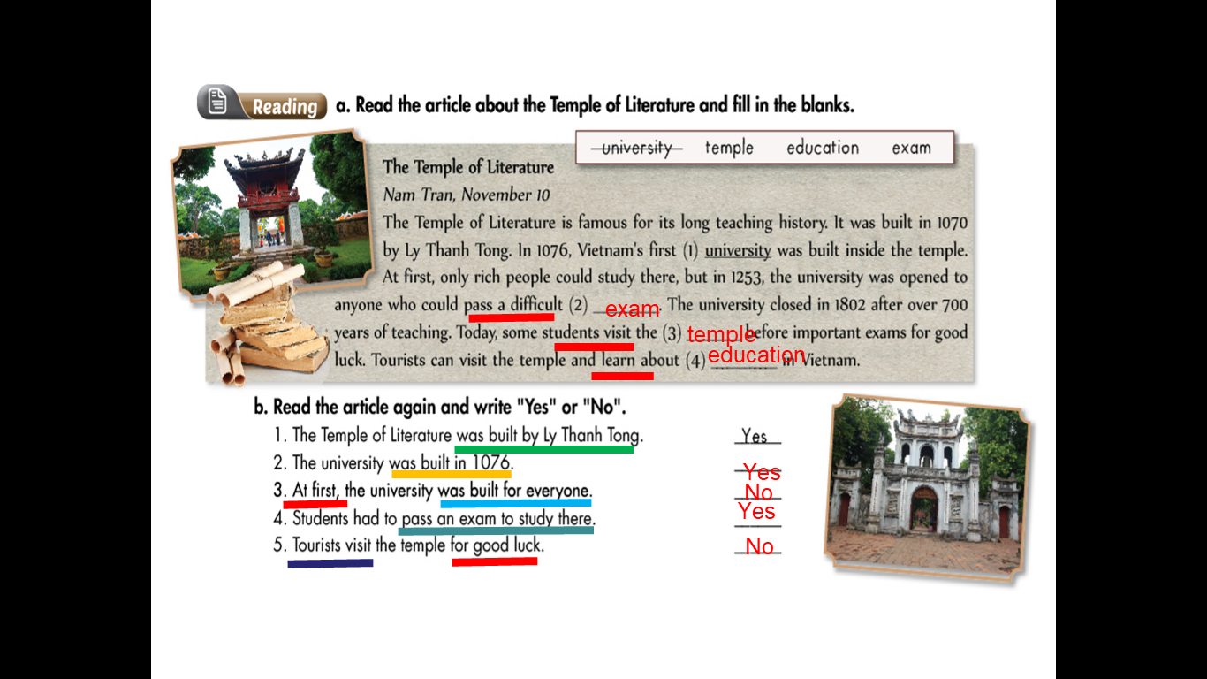
IV. Homework
1.Learnt new words by heart
2. Read the text again.
3. Prepare for the next lesson.

