UNIT 7C: ANY IDEAS?
A. Vocabulary: (write in your notebook)
- boring (adj): not interesting
- competitive (adj): sth in which people compete against each other
- hurt (v): to injure
- relaxing (adj): calming and pleasant
- expensive (adj): not cheap, costly
- difficult (adj): not easy
B. Remember: (write in your notebook)
1. - So + auxiliary verb + personal pronoun: express positive agreement
- Neither + auxiliary verb + personal pronoun: express negative agreement
Ex: I like football. – So do I. It’s very exciting. <- positive
I don’t like tennis. – Neither do I. It’s boring <- negative
2.
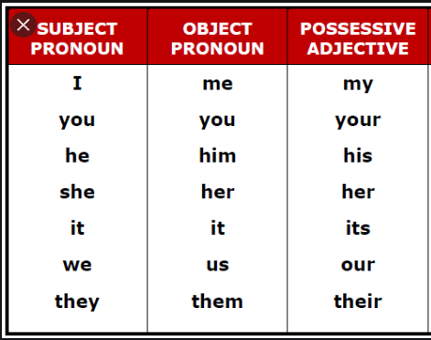 | We can use subject/ object pronouns and possessive adjective to avoid repeating the same words.  Ex: It’s Tom’s racket. Give it to him. [NOT: “Give the racket to Tom”]  - “it” (object pronoun) replaces “the racket”  - “him” (object pronoun) replaces “Tom”

3. Informal Email:
- Purpose: Write to people we know well.
- Form of an informal email: have 3 paragraphs.
Start | Dear/ Hi + the person’s first name,
1st paragraph | - Write our opening remarks and the reason for writing.
2nd paragraph | - Write the information or details we need to give.
3rd paragraph | - Write our closing remarks.
End | Love, / Take care, / Good luck, /  Our first name.
- Opening remarks: How’s it going? ; How are you?
- Closing remarks:
+ I hope I’ve helped. /That’s my advice.
+ Your feelings about what you wrote.
+ I’d better go now. / Talk to you soon.

C. Task:
* Student Book: page 76
1. Activity 1/ page 76: (write in your notebook) Look at the pictures about sports at page 76, use the given adjectives in Activity 1/ page 76, write 4 conversations, use So and Neither.
Ex:
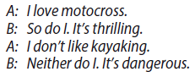

2. Activity 3/ page 76: (write in your notebook) Read the grammar note 2. Replace the words/ phrases in bold with subject/ object pronouns or possessive adjectives.
3. Read the email at page 76. Find and write all the adjectives which are used to describe the sports. Then, look up the meaning of the words and phrases in bold in a dictionary. Write them in your notebook (you may write in English or Vietnamese)
Ex: opinion: personal ideas or beliefs/ ý kiến, quan điểm
4. Activity 5/ page 76: (write in your notebook). Choose the adjectives that describe your opinions about cycling and kayaking. Fill in the table below.
 | Good points | Bad points
cycling | exciting, … | dangerous, …
kayaking

Your American pen pal can’t decide which sport to take up: kayaking or cycling. Now, based on the table above and the model email provided, write an email to your American pen pal (50 – 80 words). Ex:
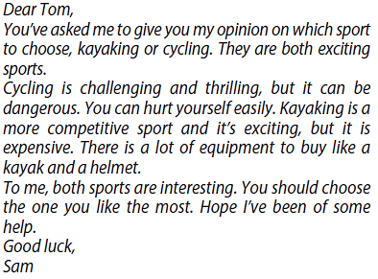
* Workbook: page 47
1. Do Ex.2/ page 47. (You may write your answers in your book)
2. Do Ex.3/ page 47. (You may write your answers in your book)
3. Do Ex.4/ page 47. (You may write your answers in your book)
4. Do Ex.5/ page 47. (You may write your answers in your book)
5. Do Ex.6/ page 47. (Write in your notebook)
Ex:
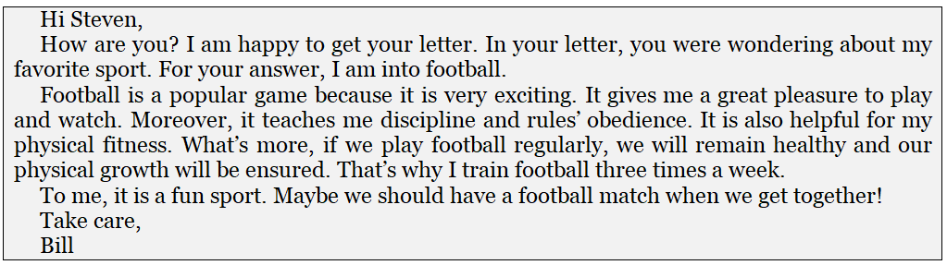

UNIT 7D: Culture Corner – SCHOOL SPORTS IN THE UK
A. Vocabulary: (write in your notebook)
Words/ Meanings |  | Words/ Meanings
- canoeing (n): a sport using and racing a canoe |  | - martial arts (n): fighting sports such as judo and karate | 
- cricket (n): a game played by two teams where you have to hit the ball with a wooden bat and run around the posts. |  | - sports clubs (n): athletic organizations in a town or area where people play sports | 
- extreme sports (n): dangerous sports (e.g., skydiving, paragliding) |  | - majority (n): a number of people or things which amounts to more than half

B. Remember: (write in your notebook)
Pie chart: generally used to show percentage (%) or comparable data. Pie charts are good for presenting data for around 6 categories or fewer.
- 60%: sixty percent
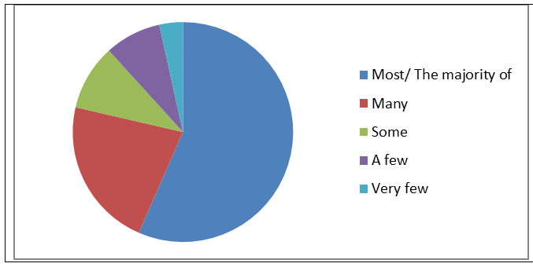

C. Task:
* Student book: page 77
1. Read the text in page 77, look up the meaning of the words/ phrases in bold. Write them in your notebook. You may write in English or Vietnamese.
Ex: primary: school for children between the ages of five and eleven/ trường tiểu học
2. Answer the questions in Activity 2/ page 77. (Write in your notebook)
3. Read Remember and do Activity 3/ page 77. (Write in your notebook)
4. Based on Activity 3/ page 77. Describe the pie chart below. (Don’t use the percentage to describe the chart)
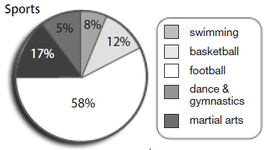
Ex: The majority of the class plays football. …

* Workbook: page 48
1. Do Ex.1/ page 48 (You may write the answers in your book)
2. Do Ex.2/ page 48 (You may write the answers in your book)
3. Do Ex.3/ page 48 (You may write the answers in your book)
4. Do Ex.4/ page 48 (You may write the answers in your book)

7E: ARE YOU OK?
A. Remember: (write in your notebook)
Word | Expressing concern
1. stomachache (n): a pain in one’s stomach  2. headache (n): a pain or aching feeling in the head  3. toothache (n): a pain in one of your teeth  4. cold (n): a common illness which makes you sneeze  5. fever (n): a rise in the temperature of the body due to illness  6. sore throat (n): a pain in one’s throat  7. cough (n): a short sound caused by coming out of lungs violently | 1. Are you OK?  2. You don’t look well.  3. I feel awful.  4. What’s wrong?  5. You should see a doctor.  6. I feel terrible.

B. Task:
* Student book:
1. Learn the vocabulary.
2. Do Ex.2 (you may write in your notebook)
3. Practice the conversation at Ex4
4. Based on the model conversation in Ex4, write a similar conversation between you and your friend. (write in your notebook) (Ex 5)

* Work book: Do Exercises (Unit 7e) (Write in your book)

UNIT 7F: CROSS-CURRICULAR CUT: HEALTH EDUCATION
A. Remember:
Word: (write in your notebook)
1. fruit (n): what grows on plants, trees, or bushes and can be eaten
2. vegetable (n): a plant like tomatoes, potatoes, onions,… which you can eat
3. dark (n): the opposite of light, closer to black than white
4. zinc (n): a natural occurring chemical essential for human growth
5. pumpkin (n): a very large orange vegetable that grows in the ground
6. affect (v): to influence, have an effect on
I
7. health (n): the physical well-being of a person
8. liver (n): a large organ in our body that cleans our blood
9. cereal (n): a breakfast food made of grain and usually eaten with milk

B. Task:
* Student book:
1. Learn the new words.
2. Ex2: Read the text and complete the sentences (write in your book).

3. Ex3: List the types of food mentioned in the text.
4. Ex4:(write in your notebook)
*Workbook book: Do exercises (Unit 7 F) (Write in your book)

UNIT 8A: SPORTS
A. Remember: (Write in your notebook)
Word | Grammar
1. can (n): a closed metal container often containing food or a drink  2. bottle (n): a container usually made of glass or plastic that is used to store liquids  3. jar (n): a glass container with a lid  4. bag (n): a container used to put things in and carry them  5. box (n): a square or rectangular container with hard sides  6. carton (n): a container made of cardboard in which food or drink is sold  7. pack (n): a collection of things in a box, bag,…sold together  8. loaf (n): a large bread that has been shaped and baked in one piece and can be cut into slices  9. create art (n): make st beautiful that people look at and admire  10.unique (adj): one of a kind  11. attract (v): to draw attention to  12.the public’s attention (phr): the interest that people show in st  13. dragon (n): a large, imaginary animal that has wings, a long tail, and breathes out fire  14.patient (adj): being able to wait calmly  15.work of art (n): a creation that is skillfully made and considered artistically valuable  16.charity (n): an organization that gives help to those in need  17. challenge (n): st that tests strength, skill, or ability, esp in a way that is interesting  18. get involved (n): get sb to be part of or donate their time, effort, or attention to st  19. donate (v): to give st to charity | - a/ an, some/ any/ every  - a/ an + N (countable, singular)  Eg: a book, an eraser  - some + N (countable, plural; uncountable: in affirmative sentences or questions making offers)  Eg:- I have some oranges.  -There’s some milk in the fridge  -Would you like some?  - any + N (countable, plural: uncountable in negative sentences or questions)  Eg: -There isn’t any water  -Are there any pens on the table?  - every + N (countable, singular)  Eg: They give every can of food to the hungry.  - Someone, everyone, anyone/ something, everything, anything  Eg: - There’s someone outside.  - Is there anyone in the room?  -I can’t do anything to help.  -Everyone is waiting for you.
   | Affirmative | Negative/ Interrogative
  People | someone, everyone | Anyone
  Things | something, everything | anything

B. Task:
* Student book:
1.* Ex 2: Read the text and answer the questions: (write in your notebook)
- Which picture shows: A dragon? A crocodile?
- What have people used to make them? Why?
* Ex 3: Choose the correct item (Do in your book)
2. Do exercises: 6, 7, 8 (in your book)
3. Do exercise 9 (Write in your notebook)

