UNIT 6 E: BACK FROM VACATION
A. Remember: (write in your notebook)
Word | Sentences
1. amazing (adj): surprising and wondrous  * Word family: amazement (n) – amaze (v) – amazed / amazing (adj) – amazingly (adv)  2. awesome (adj): sth very impressive  3. come over (phr v): to visit somebody casually  4. drop by (phr v): to visit someone informally  5. Wow! (phr): sth you say when you are surprised, impressed, or happy. | 1. Good to see you = I’m glad to see you  2. I have a wonderful time = I enjoyed every minute.  3. Lucky you! = You are very lucky.  4. I’ll drop by this afternoon = I’ll come over this afternoon.

B. Task:
* Student book: page 68
1. Learn the vocabulary.
2. Do Ex.2 (you may write in your book)
3. Practice the conversation at Ex2/ page 68.
4. Based on the model conversation in Ex2/p.68, write a similar conversation between you and your friend. (write in your notebook)
Ex:
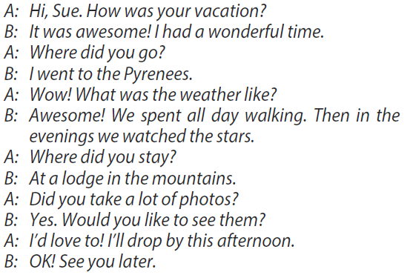

* Work book: Do Ex1, 2, and 3/ page 43 (Unit 6e)

UNIT 6F: CROSS-CURRICULAR CUT GEOGRAPHY
A. Remember:
Word: (write in your notebook) | Grammar Rules Review
1. appliance (n): a device or machine in your home that you use to do sth (washing machine,etc.) block of ice    2. block of ice (phr): frozen water in the form of a rectangle  3. feature (n): a noticeable part of sth or sb  4. furniture (n): the large moveable things in a house or office.  Inuit  5. Inuit (n): the native people of eastern Canada and Greenland.    6. oil lamp (n): a lamp that works by burning oil.  7. unique (adj): unusual  8. transport (v): to take people or goods from one place to another. | Do a revision of  1. Simple Present  2. Simple Past
  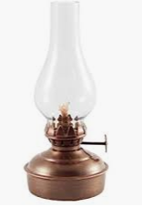  oil lamp | 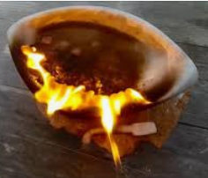  Inuit oil lamp
B. Task:
* Student book: page 69
1. Learn the new words.
2. Ex1: Under each heading, list 10 words. Then write a short paragraph about your house. (50 – 60 words) (write in your notebook). | Ex:  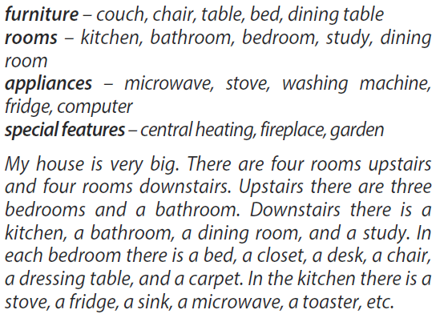

3. Ex2: Read the text at page 69. Then read the sentences, write down T (true) or F (false) (you may write in your book)
4. Ex3: Read the text and answer the questions. (write in your notebook)
5. Ex4: Find all the verbs in the text at page 69. List them in the correct column. Then write their simple present and simple past form. (write in your notebook)
Ex:
Regular | Irregular
  lived | live
  light | lit
5. Write 4 sentences about how the Inuit lived a century ago. Use Simple Past.(write in your notebook). Ex: The Inuit lived in igloos in the winter.
6. Finish Self-Check / page 70(you may write in your book)
* Work book: Do Ex1, 2, and 3/ page 44 (Unit 6f)

UNIT 7A: SPORTS
A. Remember:
Word(write in your notebook)
1. bat (n): a thick, solid stick in baseball, cricket, etc. used to hit the ball | 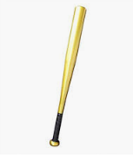 | 7. pie chart (n): a circle divided into several parts to show the relationship between a set of things. | 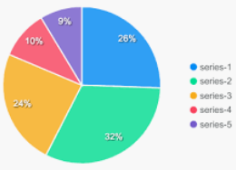
2. goggles (n): large glasses worn to protect your eyes from water, wind, etc. |  | 8. racket (n): an oval-shaped bat with strings across it used to play tennis, squash, and badminton.  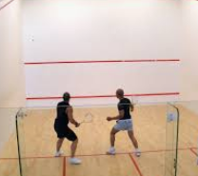  squash | 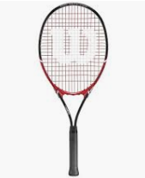
3. judo (n): a sport in which two people fight and try to throw each other on the ground |  | 9. rock climbing (n): the activity of going up cliffs and rocks. | 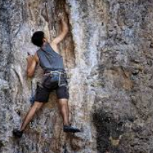
4. kayaking (n): an activity during which someone paddles in a river or a lake using a narrow boat that looks like a canoe. |  | 10. skydiving (n): an activity during which someone jumps out of the plane and opens their parachute before reaching the ground.  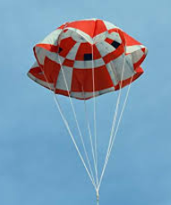  parachute | 
5. knee pads (n): the thick pieces of soft material which cover the joints in the middle of the legs to prevent injury | 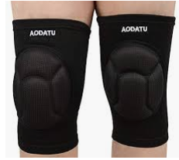 | 6. motocross (n): a sport during which the athlete rides a motorcycle over rough ground and races against other motorcyclists. | 
Learn by heart Past Participle form of Irregular Verbs(see Irregular Verbs listed at the end of Student book)
Grammar: Present perfect
Uses: Actions which started in the past and continue until now.

Affirmative form: | S + have/ has + V-ed/ V₃ + O  Ex: He has won the race.
Negative form: | S + haven’t/ hasn’t + V-ed/ V₃ + O  Ex: I haven’t finished
Interrogative form: | Have/ Has + S + V –ed/ V₃ + O?  Ex: Has she played before?
Time expressions:
- recently
- since morning
- so far
- already
- for
- just
- ever
- never
- this month/ week/ year

B. Task:
* Student book: page 72
1. Read the text at page 72. Answer the questions: (write in your notebook)
- Which thing impressed you from the text?
- Which contest would you like to watch? Why?
2. Explain the meaning of the words/phrases in bold (you may write in English or Vietnamese – write in your notebook). Then complete the sentences at Ex2/ page 72.
Ex: - weird: strange, unsual / khác thường, kì lạ (kì quặc)
3. EXERCISES: 5. 6. 7. 8. 9 (Student’s Book) (Write in your book)

UNIT 7B: INJURIES
A. Remember:
*Word:
1. make history (phr): achieve st that no one has achieved before
2. wonder (v): express a wish to know about st
3. coma (n): a state of deep unconsciousness often resulting from a serious injury
4. skull (n): the bony part of a person’s head
5. recover (v): to get better physically
6. race (n): a competition to see who’s fastest
7. lose (v): to no longer have st
8. blood (n): the red liquid that is pumped by the heart around your body
9. stitches (n): pieces of thread used to sew wounds together
10. crash (v): to hit st/ sb with force, collide
11. barrier (n): an object such as a fence or wall put in place to prevent people from moving easily from one area to another
12. passion (n): a very strong feeling
13. pay off (phr v): to be successful or profitable after a period of time
14. ahead of (prep): in front of
* Grammar: Present perfect vs. Simple past
PRESENT PERFECT | SIMLE PAST
-actions that started in the past and continue to the present.  Ex: I’ve played tennis for two years. (I’m still playing tennis) | -actions that happened at a specific time in the past.  Ex: He went fishing yesterday.
-experiences.
Ex: I’ve traveled abroad.

B. Task:
-Do exercises: 1,2,3,4,5,8,9 (Student’s Book) (Write in your book)

- Học sinh chép từ mới và làm bài theo chỉ dẩn phía trên

